DATABASE MANAGEMENT SYSTEM PROJECT TASK-1

ENES FARUK IŞIK / 180201073

**Supermarket Chain Database**

**1-)** A supermarket chain needs a database system to help for tracking the connection between customer and product. Data needs to be kept on each market branch, customers, products, workers and product category.

**2-) Entities Required:** Customer, Branch, Product, Worker, Category.

**3-) Attributes Required:**

**Customer:** Customer ID number, Customer first name, Customer last name, Customer gender.

**Branch:** Branch ID number, Branch name, Branch address, Branch phone number.

**Product:** Product ID number, Product name, Product category.

**Worker:** Worker ID number, Worker first name, Worker last name, Worker phone number, Worker gender.

**Category:** Category ID number, Category name, Category Color.

**The following relationships must be defined:**

* Branch is related to Worker.
* Branch is related to Customer.
* Branch is related to Product.
* Category is related to Product.
* Product is related to Customer.

**Connectivities and participations are defined as follows:**

* A Branch must have a Product.
* A Branch may have many Product.
* A Product may have many Branch.
* A Product must have a Branch.
* A Branch must have a Worker.
* A Branch may have many Worker.
* A Worker has only one Branch.
* A Branch may or may not have a Customer.
* A Customer may belongs to many Branch.
* A Product may or may not have a Customer.
* A Product may have many Customer.
* A Customer may have many Product.
* A Customer may or may not have a Product.
* A Category may or may not have a Product.
* A Category may have many Products.
* A Product must have a Category.

**4-)**

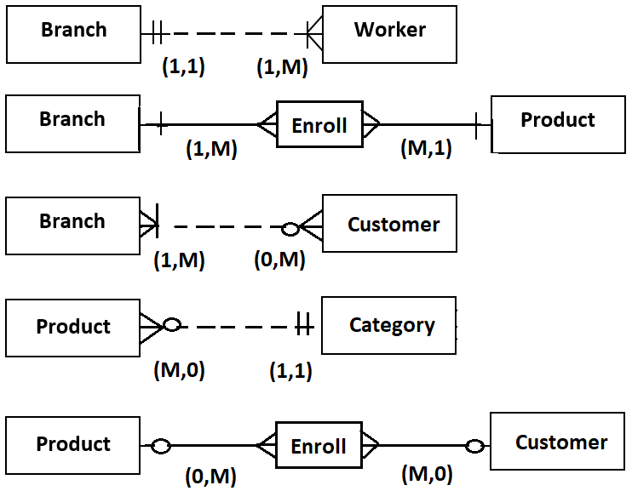

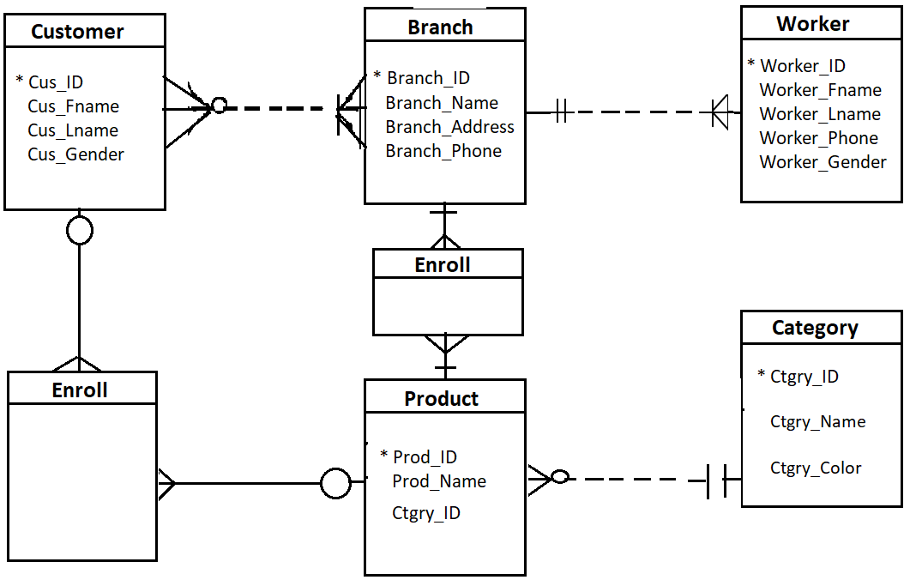**5-)**

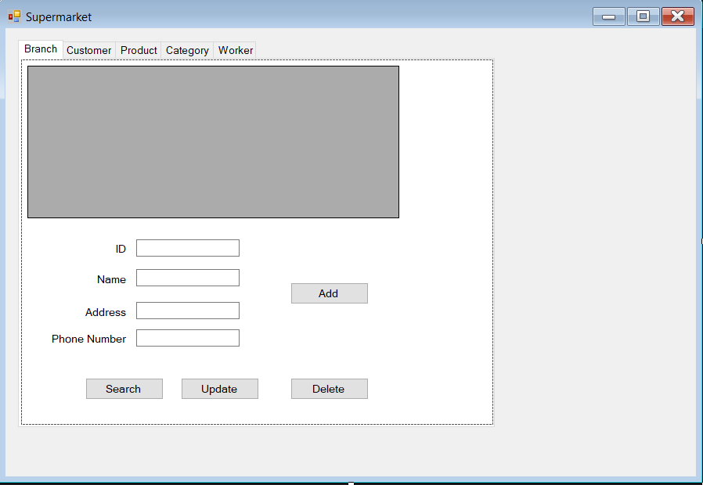**6-)**

